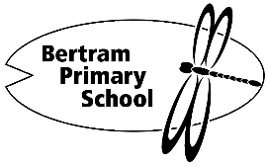
Online Services Acceptable Use Agreement (K-Year 2)

Students at Bertram Primary School are expected to demonstrate Bertram FRREE Behaviour
(Friendly, Respectful, Resilient, Engaged, Everyone is Responsible) at school, in the community
and online.

The Bertram Primary School Good Standing Policy emphasises the importance of students taking responsibility for the choices they make.

Child’s Name ___________________________ LA ______________

- I will keep my passwords private and not share with other students.
- I will not let other people logon and/or use my online account.
- I will tell the teacher if I think someone is using my online account.
- I will tell the teacher if I see anything that makes me feel uncomfortable or unsafe that I
know I should not access or view at school.
- I will say where other people’s pictures or words come from if I copy them from the internet.
- I will check with the teacher before giving information about myself or anyone else when
using online services.
- I will take care of iPads and other equipment.
- I will not use any online service to be mean, rude or unkind about other people.
- I understand online services at school are for educational purposes.
- I understand if I use the internet or my online account in a way that I should not, then I
may have consequences including losing my Good Standing.
Name of Parent/Carer _____________________________
- My child has agreed to the expectations of the Acceptable Use Agreement
- My child understands online services are provided at school for educational purposes

Signature of Parent/Carer __________________________ Date __ / __ / 2026

Note: This agreement should be filed by the school and a copy kept by the student.

